**Mechi Multiple Campus**

(Tribhuvan University)

Bhadrapur, Jhapa



**Lab Report of**

**Data Structures and Algorithm (CACS-201)**

**Implementation of Recursion**

Faculty of Humanities & Social Sciences

Tribhuvan University

Kritipur, Nepal

**Submitted By**

**Name:** Santosh Bhandari

**Roll No:** 58

**Submitted To**

Mechi Multiple Campus

Department of Bachelor in Computer Application

Bhadrapur, Jhapa, Nepal

**Program Code and Output to Calculate Factorial**

#include<stdio.h>

int fact(int n){

if(n==1|| n==0)

return 1;

else

return n*fact(n-1);

}

void main(){

int num;

printf("Enter the Number for Factorial: ");

scanf("%d",&num);

printf("Factorial = %d",fact(num));

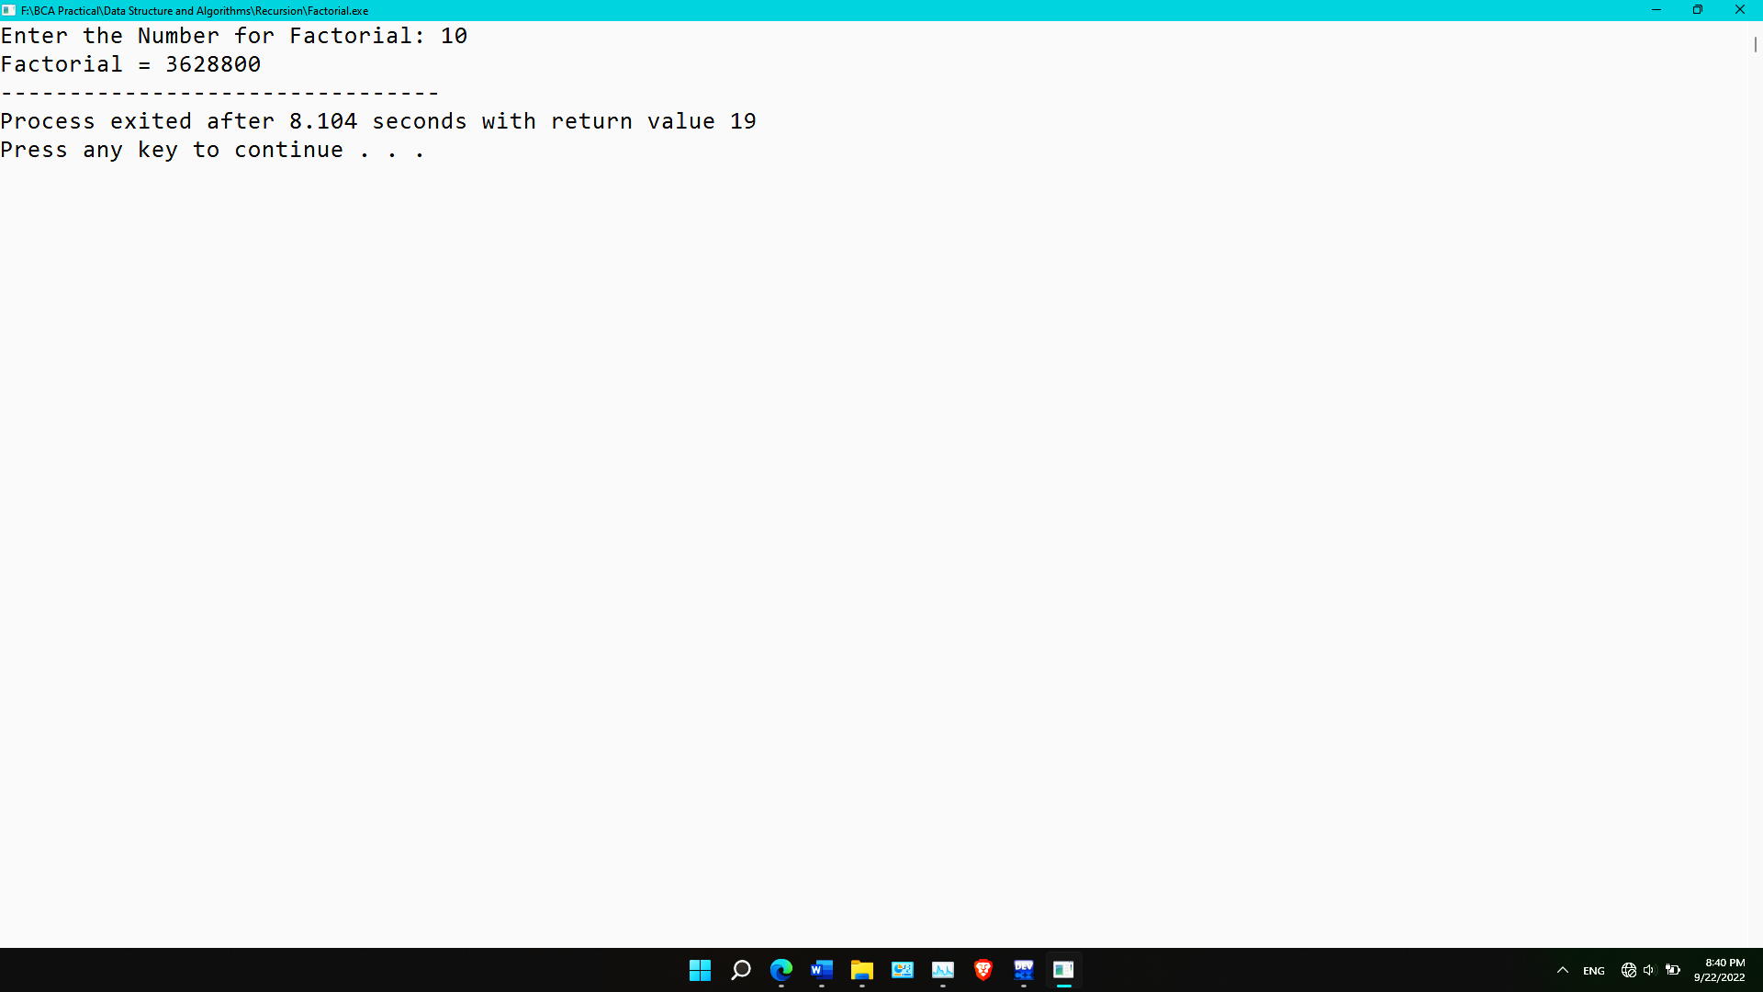}

**Program code and output to calculate the term of a Fibonacci series**

#include<stdio.h>

int fib(int n){

if(n==1)

return 0;

else if(n==2)

return 1;

else

return fib(n-1)+fib(n-2);

}

void main(){

int num;

printf("Which Term Fibonacci Number You Want: ");

scanf("%d",&num);

printf("Fibonacci Number = %d",fib(num));

}

**Program code and output to calculate the reverse of a number**

#include<stdio.h>

#include<math.h>

int Reverse(int num, int l){

if(l==1)

return num;

else

return ((num%10)*pow(10,l-1))+Reverse(num/10,--l);

}

void main(){

int num,length=0,temp;

printf("Enter the Numeber: ");

scanf("%d",&num);

temp=num;

while(temp!=0){

length++;

temp/=10;

}

printf("Reversed of Number = %d",Reverse(num,length));

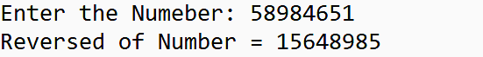}

**Program Code and Output to Check if a Number is Prime or Nor**

#include<stdio.h>

int Check(int num, int n){

if(n==0 || n==1)

return 0;

else if(num%n==0)

return 1;

else

return Check(num,n-1);

}

void main(){

int n;

printf("Enter a Number: ");

scanf("%d",&n);

if(Check(n,n-1)==0)

printf("%d is a Prime Number.",n);

if(Check(n,n-1)==1)

printf("%d is not a Prime Number.",n);

}

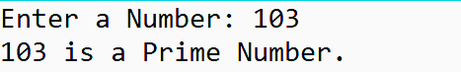

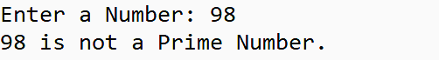

**Program code and output to solve the Tower of Hanoi**

#include<stdio.h>

void TOH(int n, char BEG[3], char AUX[3],char END[3]){

if(n>0){

TOH(n-1,BEG,END,AUX);

printf("Move From %s to %s.\n",BEG,END);

TOH(n-1,AUX,BEG,END);

}

}

void main(){

int n;

printf("Enter the Number of Disk: ");

scanf("%d",&n);

TOH(n,"BEG","AUX","END");

}

